(Approx. 1079 words)

Cutting the Paper
My Personal Features Page
By Tom Burt, Vice President
Sun City Summerlin Computer Club
https://www.scscc.club tomburt89134 (at) cox.net

Here in Sun City Summerlin (Las Vegas), the local paper is the Las Vegas Review Journal. When Mrs. Burt and I first moved here about 21 years ago, the "RJ" was a substantial paper with lots of news, features, and editorial content. We had a 7-days a week subscription, and the morning read was a regular part of our day.

As time passed and the paper changed hands, the price steadily crept up, the physical size of the paper grew smaller, and the page stock thinner. The news content also diminished, and the quality of the writing suffered. In simple terms, we were steadily being charged more for less.

Also, as we grew older and less spry, going out in the morning to retrieve the paper from our steep driveway became an onerous chore – especially in the chilly winter months. And, of course, all that paper was going right back into the recycle bin – especially on Sunday when we would pretty much toss all the expensive color ad supplements.

About two years ago, when the renewal price went over $153.40 a year, we decided to cancel the "RJ" and get our news from the Internet and the TV. We've never regretted that decision. However, we did miss the comics and features. So, my inner geek decided to do a little work to locate replacements on the Internet and assemble all of the hyperlinks onto a simple, personal web page that I can launch from my Windows desktop.

Comics

Two major comics services offer a large selection of free comics. These are:

https://gocomics.com and https://comicskingdom.com. I also link to https://dilbert.com to get the daily and Sunday Dilbert comics by Scott Adams. You can search or browse these sites and then save the links to comics you like. All these comics, even the dailies, are in color, and you can scroll back in time if you miss a few days.

Sports Sites

I have links to most major sports websites like https://PGAtour.com, https://NFL.com, and so on to check standings, schedules, and major sports news. I'm mainly a golf, football, and auto racing fan, but you can link to any sites you like.

Puzzle Sites

I have links to several crossword puzzle and word game sites. My favorite is the AARP daily crossword – hard enough to be challenging, easy enough to be done in 10 minutes or less, and they time and score you. About once a week, I can score a top 1890.

Other Handy Sites

I have a link to the Old Farmer's Almanac website to get astronomical data and other news. I have a link to the Review Journal's website so that I can check local news headlines. I have links to the local supermarket websites where the weekly food pages are online. And I have a link to the https://www.TitanTV.com website with the schedules for DirecTV in Las Vegas to check schedules for TV programming. And I have a link to https://ZDNet.com to check on Computer and Technology news.

How to Do Your Own

Here's what my "Personal Features" web page looks like in my web browser:

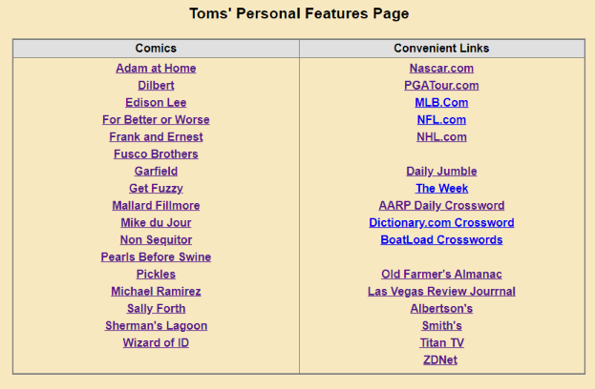

I used a simple two-column table to organize the content. Then, when each link is clicked, it opens the target page in a new browser tab. That makes it easy to view all the comics without hitting the back button after each one.

Editing the Features Page

Since I'm also our club's Webmaster, I have some fairly powerful software tools for web page editing – notably Microsoft Expression Web 4 and Visual Studio 2019. Both of these can be downloaded for free at https://Microsoft.com in the Downloads section. However, these tools, while relatively easy to use, do require some learning.

If you have MS Word or LibreOffice Writer, you can open an existing HTML document or create a new document and save it as HTML. In the document, you can use any layout or organization that appeals to you. You could even use images in place of or along with the link titles.

The key actions to create a new link are:
- In your web browser, browse to the website or comic you wish to link to.
- Copy (Ctrl+C) its hyperlink from the address bar of your browser to the clipboard.
- In the web page editor (e.g., Expression Web 4), type in the comic's name or feature into a new line on the web page.
- Select that block of text and right-click.
- From the popup menu that appears, choose "hyperlink" or "edit hyperlink" (depending on your editing tool).
- A hyperlink editing dialog will appear, displaying the text you highlighted in the "Text to display" box.
- Paste (Ctrl+V) the copied actual hyperlink into the "Address" box in the dialog.
- Click the Target Frame button. A secondary dialog will open (see below). Choose "New Window" from the list. If it's enabled, check the box to set that option as the default for all other hyperlinks on your features page. Then you won't need to set the target frame on each link you create explicitly.

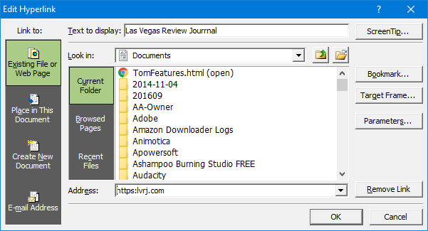

MS Expression Web Hyperlink Editor

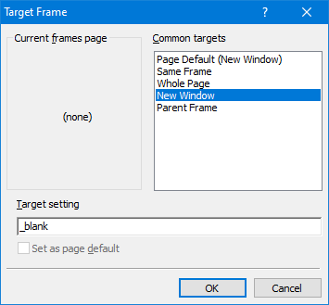

MS Expression Web - Target Frame Dialog

The hyperlink dialogs are similar if you're using MS Word or Libre Office to edit your Favorites page.

You can also change the fonts, colors, and highlighting effects on the page and links to suit your preferences.

Conclusions

For us, cutting the paper wasn't about saving money; it was about not getting VALUE for our money and about convenience. It was also in a small way about saving some natural resources by eliminating paper; even though the used newsprint is supposedly recycled, a lot of it isn't.

The Internet is a vast resource for news and entertainment of all kinds, with much of it free (admittedly with ads, but you can ignore those). So my selection of comics features is very modest – just enough for about half an hour a day. And what's great is they take up no space and don't have to be toted out to the recycling bin and thence to the curb once a week.

Even if you decide to keep your subscription to the local paper, you may want to set up a features page like mine. The RJ's selection of comics wasn't the best. The ones on my page are ones I enjoy.

